Design and Implementation of a hybrid (Relational / XML) database system of Hermits Pet Clinic

Introduction
This report details the development process of a hybrid database system for a virtual pet clinic named as Hermits Pet Clinic. The development of this hybrid database system will serve as a replacement of the paper-based pet management process that they currently this. To detail this, the next section will provide details of the paper-based system currently in use, the scope of the database in terms of how much of the functionality will be implemented, a list of business requirements that the database system will need to fulfill, a list of business rules that will guide of different entities of the database will relate and a relational schema. Once the design is done, an implementation of the database will be done on the MS SQL Server. (Blinn, 2019)

Business Case
Hermits pet clinic specializes in the treatment of pets which are of different types. To accomplish this, it has several employees who are either doctors, nurses or receptionist. They have a paper-based system which involves the receptionist recording registration of pets and their owners as well as booking of appointments with each of these two categories of documents being stored in a manual filing system. To register or book an appointment, the owners usually call the clinic for either routine checkups or a new appointment. During this call, the owners schedule a physical consultation at a fee. The consultations are charged based on the following table (Iannetti et al., 2019)
Pet Age in Years | Consultation Fee
0-10 | $10
10-15 | $15
15-20 | $20

During the consultation, the doctor assesses the condition of the pet and gives a diagnosis and also assesses whether there is need to schedule an appointment. A consultation has no nurse and only 1 doctor whereas an appointment always has at least two nurses and at least 1 doctor. If there is need, the pet owner follows up later to schedule an appointment. Additionally, the owners have an option to cancel an appointment if they deem it necessary. In such a case, the owner would incur a cancellation fee of $10. There is a fixed appointment fee of $5 for each appointment. (Iqbal et al., 2021)
Registrations are stored in the registration diary document which captures the details of the pet such as its name and its type, the details of the owner which include the name and the age.
The appointments are maintained within the appointment diary document which captures information about the date and time of the appointment, the nurses and doctors assigned to the appointment, the attendance of the appointment and the appointment fee as well as any cancellation fees.
After a consultation, the doctor gives a diagnosis that is recorded on the consultation diary containing the description of the diagnosis, the medication, the cost of medication as well as a pharmacy recommendation where they can get buy the medication.
The recommended pharmacy creates a copy of this diagnosis once the pet owner gets the medication and then updates this copy with their stock levels of that medication. The pet owner takes this copy back to the clinic.
Maintaining and accessing this paper work is a tedious process for all the stakeholders involved. This has necessitated the creation of a database system to manage this information. (Ma, 2021)

Scope of the database
The database to be created will be comprehensive enough to completely replace the paper-based system. In that case the database will allow the collection, storage and maintenance of information regarding the pets and their owners, information about the employees of the clinic, information about consultations, appointments and the resulting diagnosis made.

Business Requirements
The database needs to meet the following business requirements
- The database should allow information about the pets and their owners to be retrieved.
- The database should allow information about the pets in consultation within a certain age range to be retrieved
- Through a user defined function, the database should allow information about the total fees that an owner has been billed for their pet to be retrieved based on the ID of the pet.
- The database should allow custom XML data to be defined and stored for the pharmacy and the medication.
- The database should allow both the XML and non-XML data about a pharmacy to be retrieved.
- The database should allow the XML data in the medication data to be modified.
- The database should allow the medication data of a predefined pet, to be searched and retrieved.

ERD and Relational Schema

Entity Relationship Diagram (ERD)
Based on the paper-based system for the clinic, the following main documents can be established as the main entities
- Appointment Diary
- Registration Diary
- Consultation Diary
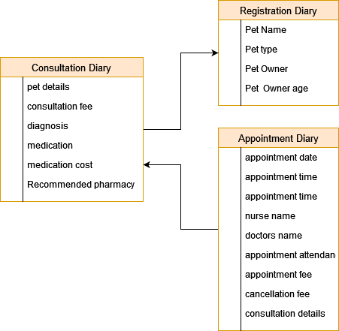
The resulting ERD based on these documents is as below:

3NF
In 3NF the database data redundancy / repetition is eliminated and data integrity is enforced. To achieve this in the database the following procedure was followed (Saha Bagui & Earp, 2022):
- The registration diary was decomposed into the pet’s entity and the pet owner’s entity
- The consultation diary was decomposed into the consultation, pharmacy, Prescription, medication and stock entities.
- The appointment diary was decomposed into the appointment, employees and personnel entities.
Using this 3NF structure and the business requirements, the full entity list and the corresponding attributes are as follows:
Entity | Attributes | Type
Employee | - Employee number  - Category  - Office number  - Telephone number  - Gender  - Email | Strong
Pet | - Name  - Age  - Type  - Breed  - Weight  - Color  - Gender | Strong
Pet Owner | - Name  - Gender  - Age  - Telephone number  - Address | Strong
Pharmacy | - Name | Strong
Consultation | - Consultation number  - Diagnosis Description  - Appointment required  - Consultation fee | Strong
Prescription | Attributes from Medication and consultation | Weak
Medication | - Medication number  - Medication name  - Medication cost | Strong
Stock | - Quantity | Strong
Appointment | - Date  - Time  - Status  - Appointment fee  - Cancellation fee | Strong
Personnel | Attributes from employee and Appointment | Weak

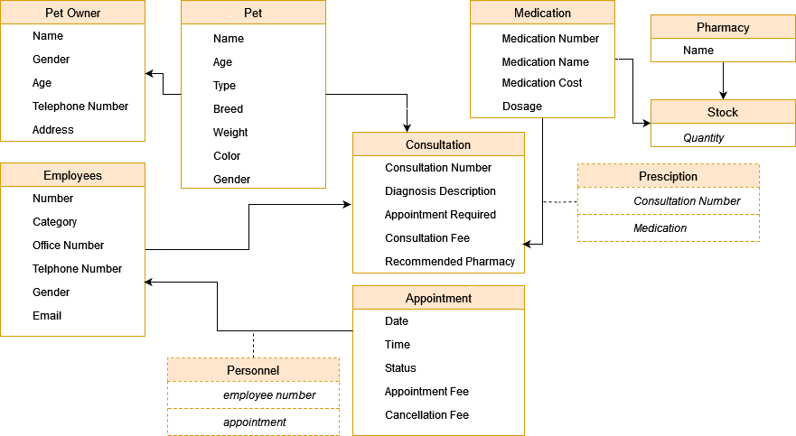
The resulting 3NF ERD database structure is shown below:

Business Rules
To generate the relational schema the database will need to follow the following business rules:
- A pet owner can have multiple pets
- A consultation can be set up for multiple pets
- A consultation should only have one employee who is a doctor
- A consultation can have multiple prescriptions
- A prescription can have multiple medications
- A medication can be stocked by multiple pharmacies
- An appointment can be set up for multiple pets
- An appointment can have multiple personnels who are either doctors or nurses
- The ages of pets should be between 0 to 20 years
- The gender for the pets, employees or owners will either be M or F to denote male and Female

Relational Schema
To generate the relational schema, the following were considered
- The 3NF structure
- The business requirements
- The business rules
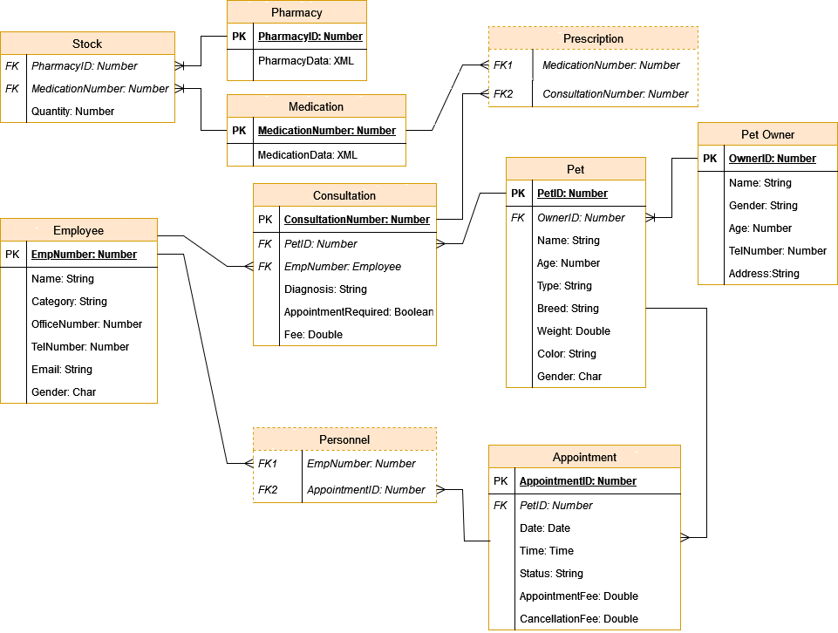
The resulting relational schema is shown below:

Conclusion
This report introduces a concise and succinct business case and provides as much details as possible to make easy for the inclusion of XML data, generation of ERD and a consequent relational schema that satisfies the third normal form (3NF) of database normalization. The schema design provides the ground work for the eventual implementation of the hybrid database system using the MS SQL database server.

References
Blinn, E. (2019). SQL Server Reporting Services Encryption Key. Managing SQL Server Encryption Certificates. https://doi.org/10.1007/978-1-4842-5151-5_3
Iannetti, S., Savini, L., Palma, D., Calistri, P., Natale, F., Di Lorenzo, A., Cerella, A., & Giovannini, A. (2019). An integrated web system to support veterinary activities in Italy for the management of information in epidemic emergencies. Preventive Veterinary Medicine, 113(4), 407–416. https://doi.org/10.1016/j.prevetmed.2014.01.015
Iqbal, N., Jamil, F., Ahmad, S., & Kim, D. (2021). A novel blockchain-based integrity and Reliable Veterinary Clinic Information Management System using predictive analytics for provisioning of Quality Health Services. IEEE Access, 9, 8069–8098. https://doi.org/10.1109/access.2021.3049325
Ma, F. (2021). Platform Construction of Veterinary Management Information System based on GIS. 2021 4th International Conference on Information Systems and Computer Aided Education. https://doi.org/10.1145/3482632.3487436
Saha Bagui, S., & Earp, R. W. (2022a). Beyond the first entity diagram. Database Design Using Entity-Relationship Diagrams, 107–128. https://doi.org/10.1201/9781003314455-5

